Keynotes
2016 UAHPERD Annual Conference
Weber State University
March 19, 2016
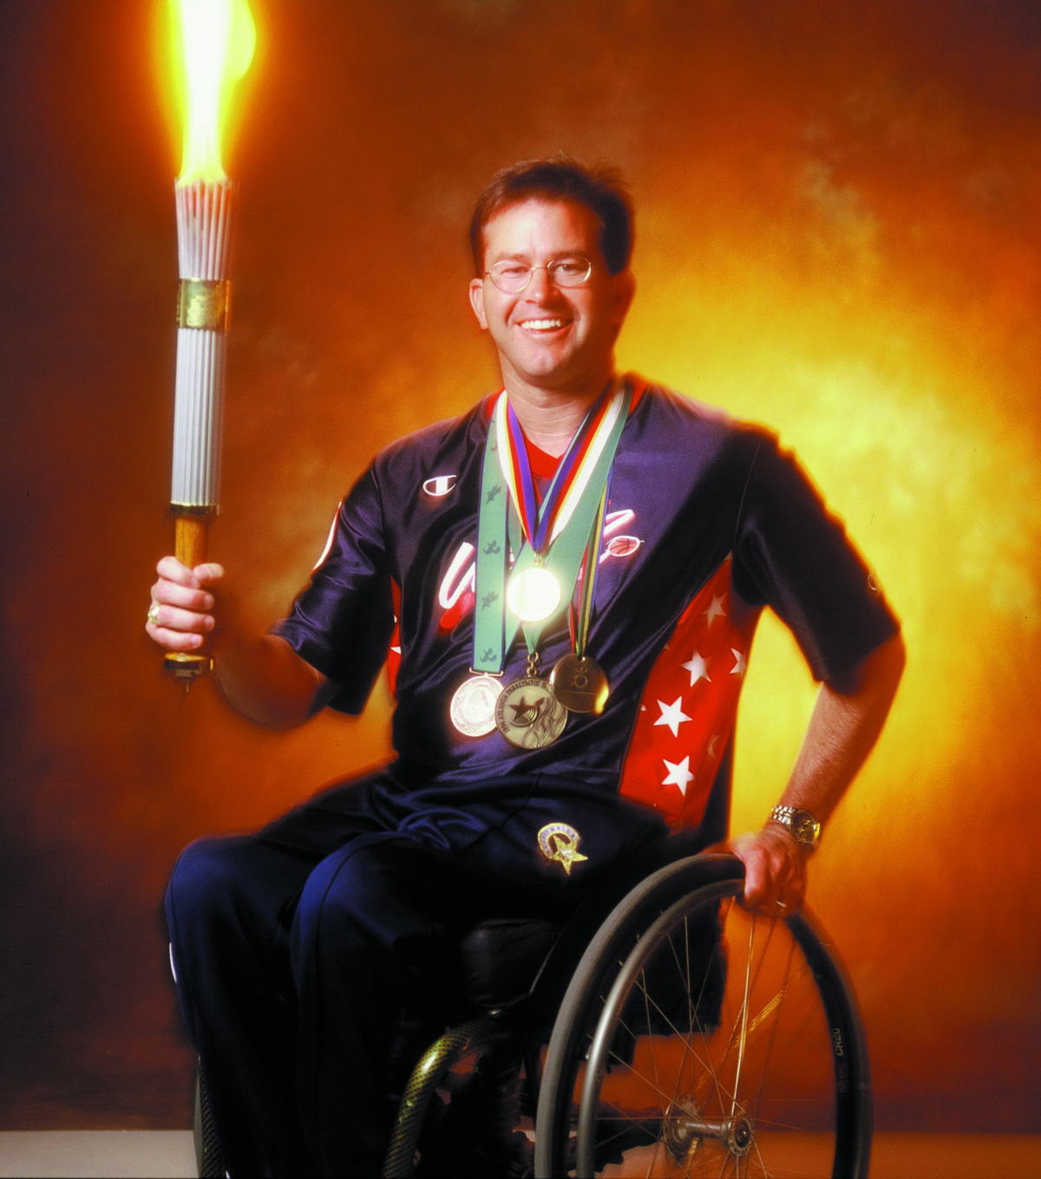
Mike Schlappi: Speaker, Author, and Gold Medalist
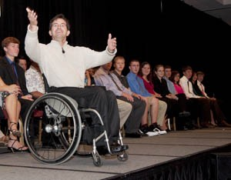
When Mike Schlappi takes the floor, a dazzling smile greets you. Then, you notice the wheelchair. If ever a man was defined by what he can do, instead of what he cannot do, it is Mike Schlappi. This Hall of Fame athlete, Gold Medalist, World Champion, MBA, CSP, businessman, husband and father of five will entertain you and inspire you to take on and overcome your own limitations. Following a tragic accident as a teenager, Mike has proven that just because “you can’t stand up, doesn’t mean you can’t stand out”!

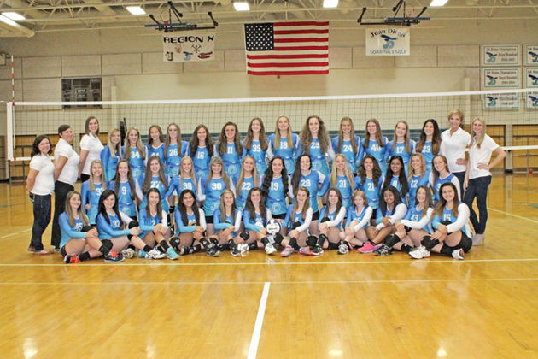
Mary Nickles with KUTV News: Anchor, Mom, Coach, Cancer Survivor
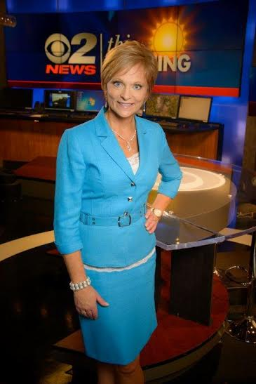
In addition to being a news anchor for KUSTV News since 1991, Mary is very active in our community as a mentor for young people and as an advocate for health. She is Chair of the Advisory Board for Head Start, and is on the Board for the Intermountain Catholic Newspaper and for the Police Athletic League. She donates home-cooked meals and many hours to help other charities, including The Ronald McDonald House, Guadalupe Schools, Life After Breast Cancer, The Multiple Sclerosis Society, and the Heart Walk. Mary participated in the Utah Summer Games for years, and was inducted into the Hall of Honor in 2003. She also played professional volleyball for the Utah Predators. Mary and her husband, Kent, live in the Salt Lake Area and are the parents, tutors, coaches, ATMs and agents for their twins, Zachary and MacKenzie, who started their freshman year at the University of Utah this year.
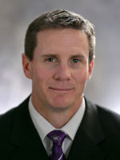
Jay Hill: Weber State University Football Head Coach
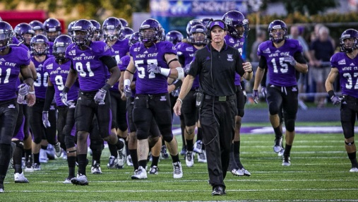
Jay is the head football coach at Weber State University. After just two seasons at WSU, Jay has resurrected the football program and led them to their first winning record in 4 years this past fall. Prior to Weber State, Jay spent 13 years (2001-13) at Utah, including the last nine seasons as a full-time assistant coach under Kyle Whittingham. Prior to that, he spent four years as a graduate assistant and administrative assistant with the Utes under legendary coaches Ron McBride and Urban Meyer. The Lehi, Utah native played college football at Ricks Junior College, where he earned junior college All-American honors at cornerback. He went on to play two seasons (1998-99) at Utah under Ron McBride. As a senior he led the Mountain West in interceptions, was named Utah’s Defensive MVP and earned second team All-Conference honors. He later played briefly in the XFL and signed free agent contracts with the Buffalo Bills and New York Giants. He and his wife Sara have four children: Ashtyn, Alayna, Allie and Jacob.

